R Assignment 2

Jacey Davies

9/30/2020

## Exercise 4.1

1. Store the following vector of 15 values as an object in your workspace: c(6,9,7,3,6,7,9,6,3,6,6,7,1,9,1). Identify the following elements:
2. Those equal to 6
3. Those greater than or equal to 6
4. Those less than 6 + 2
5. Those not equal to 6

#Storing the vector  
v1 = c(6,9,7,3,6,7,9,6,3,6,6,7,1,9,1)  
  
#Finding the elements equal to 6  
v1[v1==6]

## [1] 6 6 6 6 6

#Finding the elements greater than or equal to 6  
v1[v1>=6]

## [1] 6 9 7 6 7 9 6 6 6 7 9

#Finding the elements less than 6 + 2  
v1[v1<(6+2)]

## [1] 6 7 3 6 7 6 3 6 6 7 1 1

#Finding the elements not equal to 6  
v1[v1!=6]

## [1] 9 7 3 7 9 3 7 1 9 1

1. Create a new vector from the one used in (a) by deleting its first three elements. With this new vector, fill a 2 × 2 × 3 array. Examine the array for the following entries:
2. Those less than or equal to 6 divided by 2, plus 4
3. Those less than or equal to 6 divided by 2, plus 4, after increasing every element in the array by 2

#Creating a new vector by deleting the first three elements of v1  
v2 = v1[-1:-3]  
  
#Filling a 2 x 2 x 3 array with this vector  
ar1 = array(data=v2, dim=c(2,2,3))  
  
#Examining the array for elements less than or equal to 6 divided by 2, plus 4  
log1 = ar1<=(6/2+4)  
log1

## , , 1  
##   
## [,1] [,2]  
## [1,] TRUE TRUE  
## [2,] TRUE FALSE  
##   
## , , 2  
##   
## [,1] [,2]  
## [1,] TRUE TRUE  
## [2,] TRUE TRUE  
##   
## , , 3  
##   
## [,1] [,2]  
## [1,] TRUE FALSE  
## [2,] TRUE TRUE

#Increasing every element in the array by 2  
ar2 = ar1 + 2  
  
#Finding the elements less than or equal to 6 divided by 2, plus 4  
log2 = ar2<=(6/2+4)  
log2

## , , 1  
##   
## [,1] [,2]  
## [1,] TRUE FALSE  
## [2,] FALSE FALSE  
##   
## , , 2  
##   
## [,1] [,2]  
## [1,] FALSE FALSE  
## [2,] TRUE FALSE  
##   
## , , 3  
##   
## [,1] [,2]  
## [1,] FALSE FALSE  
## [2,] TRUE TRUE

1. Confirm the specific locations of elements equal to 0 in the 10 × 10 identity matrix I10 (see Section 3.3).

#Creating the identity matrix I10  
I10 = diag(x=10)  
  
#Finding the specific locations of elements equal to 0  
which(x=(I10==0))

## [1] 2 3 4 5 6 7 8 9 10 11 13 14 15 16 17 18 19 20 21 22 24 25 26 27 28  
## [26] 29 30 31 32 33 35 36 37 38 39 40 41 42 43 44 46 47 48 49 50 51 52 53 54 55  
## [51] 57 58 59 60 61 62 63 64 65 66 68 69 70 71 72 73 74 75 76 77 79 80 81 82 83  
## [76] 84 85 86 87 88 90 91 92 93 94 95 96 97 98 99

1. Check whether any of the values of the logical arrays created in (b) are TRUE. If they are, check whether they are all TRUE.

#Checking whether any of the values of the first logical array are TRUE  
any(log1)

## [1] TRUE

#Checking whether all of the values of the first logical array are TRUE  
all(log1)

## [1] FALSE

#Checking whether any of the values of the second logical array are TRUE  
any(log2)

## [1] TRUE

#Checking whether all of the values of the second logical array are TRUE  
all(log2)

## [1] FALSE

1. By extracting the diagonal elements of the logical matrix created in (c), use any to confirm there are no TRUE entries.

#Extracting the diagonal elements of the logical matrix  
diag(I10) = 0  
  
#Using any to confirm there are no TRUE entries  
any(I10)

## [1] FALSE

## Exercise 16.2

Every Saturday, at the same time, an individual stands by the side of a road and tallies the number of cars going by within a 120-minute window. Based on previous knowledge, she believes that the mean number of cars going by during this time is exactly 107. Let X represent the appropriate Poisson random variable of the number of cars passing her position in each Saturday session. a. What is the probability that more than 100 cars pass her on any given Saturday?

λ = 107

P(X > 100) = 1 - P(X ≤ 100) = 1 - $\sum_{x=0}^{100}{\frac{{(λt)}^{x}e^{-(λt)}}{x!}}$ or with R:

1-ppois(100,107)

## [1] 0.7319128

P(X > 100) = 0.7319

1. Determine the probability that no cars pass.

P(X = 0) = $\frac{{(λt)}^{x}e^{-(λt)}}{x!}$ $=\frac{{(107)}^{0}e^{-107}}{0!}= e^{-107}$ or with R:

dpois(0,107)

## [1] 3.39227e-47

P(X = 0) = 3.392 x 10^-47

1. Plot the relevant Poisson mass function over the values in 60 ≤ x ≤ 150.

barplot(dpois(x=60:150,lambda=107),ylim=c(0,0.05),space=0,names.arg=60:150,ylab="Pr(X=x)",xlab="x")

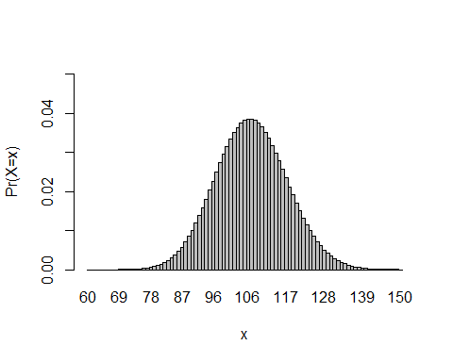

1. Simulate 260 results from this distribution (about five years of weekly Saturday monitoring sessions). Plot the simulated results using hist; use xlim to set the horizontal limits from 60 to 150. Compare your histogram to the shape of your mass function from (c).

hist(rpois(n=260,lambda=107), xlim=c(60,150),ylab="Cars Passing",xlab="x")

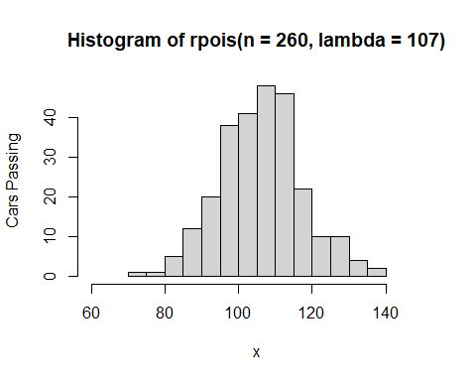

The histogram does not fit the bell curve shape as well as the mass function does. This is most likely because the mass function comes from theoretical values of the expected probabilities for each value of x, while the histogram comes from an experimental, random sample of 260. Thus it is less “perfect” than the theoretical mass function.